# **Summary:**

This report provides an in-depth analysis of the customer churn rate, focusing on identifying key factors contributing to churn, the demographic characteristics of churned customers, and the financial implications of customer attrition. The findings are based on a dataset comprising customer demographics, service usage, payment methods, and other relevant attributes. The report also includes visualizations and insights that can guide strategic initiatives to reduce churn and improve customer retention.

1)INTRODUCTION: Customer churn, or attrition, is a critical metric for businesses, particularly in subscription-based industries. Understanding why customers leave and identifying patterns in churn behaviour can help companies develop strategies to retain customers, improve services, and ultimately enhance profitability. This report aims to explore the factors driving customer churn and provide actionable insights to minimize it.

2) Data Overview: The dataset used in this analysis includes 38 columns with information on customer demographics, service usage, payment methods, and churn status. Key variables analysed include:

* **Demographics**: Age, Gender, Marital Status, Number of Dependents
* **Geographic Information**: City, Zip Code, Latitude, Longitude
* **Service Usage**: Internet Type, Streaming Services, Online Security
* **Financial Metrics**: Monthly Charge, Total Charges, Total Revenue
* **Customer Status**: Churn Category, Churn Reason

**3) Churn Rate Analysis:**

**3.1 Overall Churn Rate**

The overall churn rate in the dataset is calculated by dividing the number of churned customers by the total number of customers. This rate serves as a baseline metric for evaluating customer retention strategies.

**3.2 Churn by Demographics**

* **Age**: The analysis revealed that certain age groups, particularly younger customers, exhibited higher churn rates. Customers aged 18-35 were more likely to churn, potentially due to lower brand loyalty or a greater tendency to switch to competitors.
* **Gender**: There was no significant difference in churn rates between male and female customers.
* **Marital Status**: Single customers had a slightly higher churn rate compared to married customers, possibly due to different financial priorities or service usage patterns.

**3.3 Churn by Geographic Location**

* **Top 5 Cities with Highest Churn**:
  + **San Diego** (185 churned customers)
  + **Los Angeles** (78 churned customers)
  + **San Francisco** (31 churned customers)
  + **San Jose** (29 churned customers)
  + **Sacramento** (26 churned customers)

These cities represent the largest concentrations of churned customers. The high churn in these areas could be influenced by factors such as competition, service quality, or demographic characteristics.

**3.4 Churn by Service and Payment Method**

* **Internet Service**: Customers using DSL had a higher churn rate compared to those using fibre or cable internet. This may indicate dissatisfaction with service speed or reliability.
* **Payment Method**: Customers who used bank withdrawal as a payment method were more likely to churn compared to those using credit cards. This could be due to the flexibility and perceived security of credit card payments.

**4. Financial Impact of Churn**

The financial analysis focused on the revenue loss associated with churn. High churn rates among customers with higher monthly charges (e.g., premium subscribers) resulted in significant revenue loss. Calculating Customer Lifetime Value (CLTV) further highlighted the impact, showing that retaining high-value customers is crucial for maintaining profitability.

**5. Key Findings and Insights**

* **Service Quality and Value**: Poor service quality (e.g., slower internet speeds) and lack of value-added services were major factors driving churn.
* **Payment Method Preferences**: Customers prefer flexible and secure payment options, and those dissatisfied with their payment method were more likely to churn.
* **Geographic Targeting**: Certain cities have higher churn rates, suggesting that targeted retention strategies should be implemented in these areas.

**6. Recommendations:**

Based on the analysis, the following recommendations are proposed to reduce churn:

1. Enhance Service Quality: Focus on improving internet speed and reliability, particularly for DSL users, to reduce dissatisfaction.
2. Flexible Payment Options: Offer more flexible payment options, including incentives for customers to use secure and convenient methods like credit cards.
3. Targeted Retention Campaigns: Implement targeted retention strategies in high-churn cities like San Diego and Los Angeles, possibly through personalized offers or improved customer service.
4. Customer Engagement: Increase engagement with younger customers to build loyalty, perhaps through loyalty programs or exclusive offers for long-term subscribers.

.

**Based on the Data following data is been visualized:**

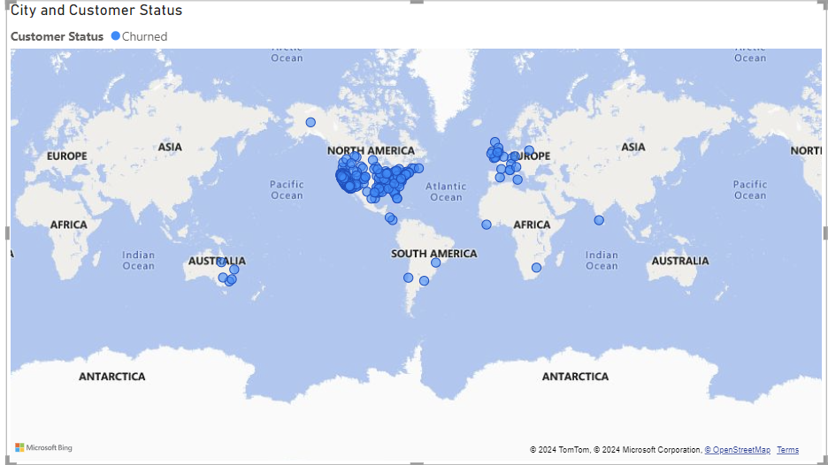1 Geographical distribution of churn:

In above Map it is clearly visible Most number of churn customers is from north America and Europe is also been customers churned after north America. Some Parts of Australia also been visible.

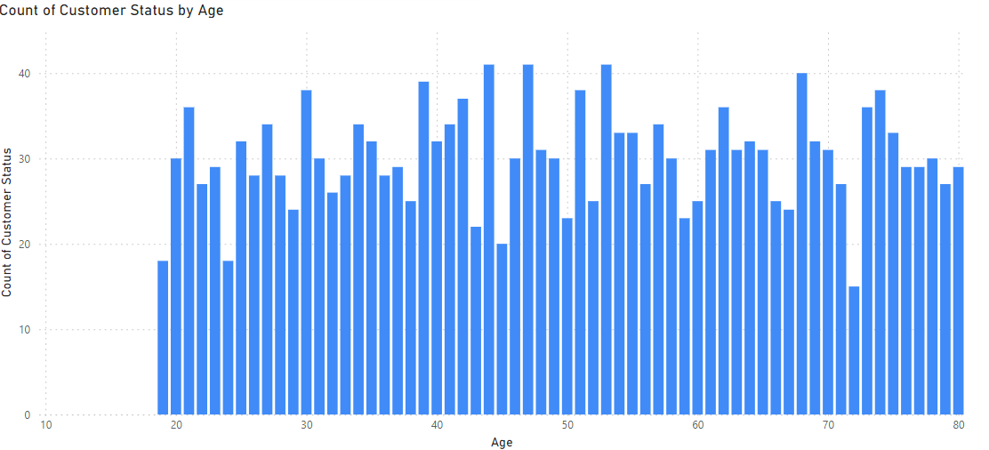2 Churn Rate by Group:

In above analysis Most of from age 44,47 and 53 have been churn the services and age 72 has minimum number of churn rate.

3 Churn Rate by contract type;

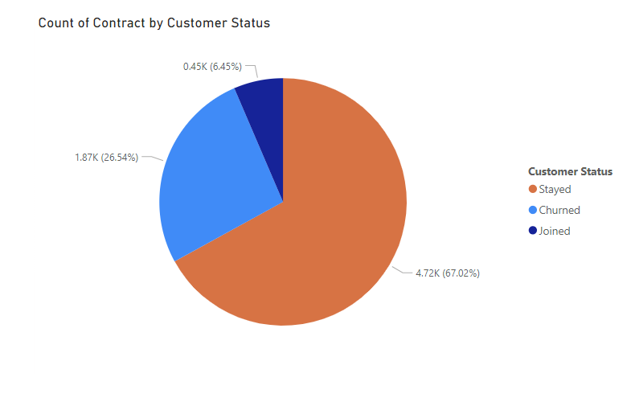

In the above pie diagram 26.54% is been churned. And others are stayed and newly joined in the telecom industry.

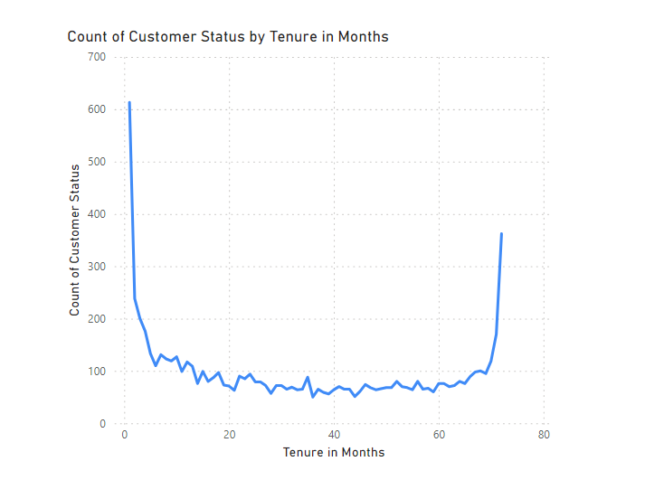4 Churn By Tenure:

IN the above Line chart the count of customer status in months is been analysed and how months have been calculated.

7) Conclusions: Understanding and addressing customer churn is essential for sustaining growth and profitability. This report highlights the key factors driving churn and provides actionable insights to mitigate it. By focusing on service improvement, payment flexibility, and targeted retention efforts, businesses can effectively reduce churn and enhance customer satisfaction